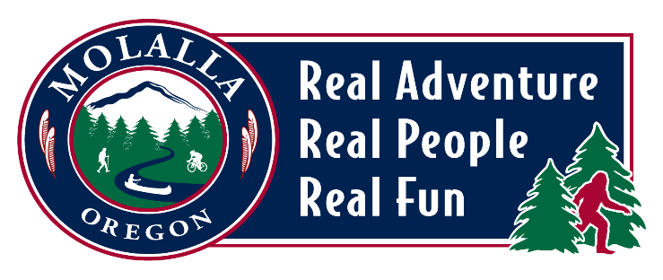

**CITY OF MOLALLA**

**BEAUTIFICATION & CULTURE COMMITTEE**

**MEETING AGENDA**

**Meeting Location: Molalla Area Chamber of Commerce**

**109 E Main Street**

**Tuesday, February 11, 2025 | 5:30pm**

**\*\*\*This meeting cancelled. Next meeting is March 11, 2025\*\*\***

* **CALL TO ORDER & WELCOME**
* **ROLL CALL**
* **MINUTES**
* **GENERAL BUSINESS**
* **OLD BUSINESS**
* **FOR THE GOOD OF THE ORDER**
* **ADJOURN**