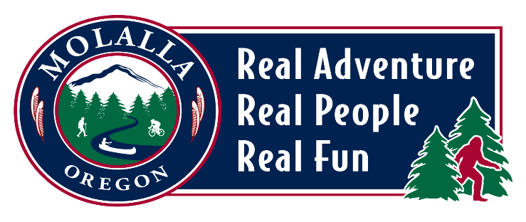

**CITY OF MOLALLA**

**BEAUTIFICATION & CULTURE COMMITTEE**

**MEETING AGENDA**

**Meeting Location: Molalla City Hall**

**117 N Molalla Avenue**

**Monday, April 21, 2025 | 5:30pm**

* **CALL TO ORDER & WELCOME**
* **ROLL CALL**
* **MINUTES**
* **GENERAL BUSINESS** 
  + **New Meeting Day for the Committee**
  + **Serial Communication to B&C Committee April 1, 2025**
  + **Banners and Banner System Proposal**
  + **Grant Opportunities**
  + **Future/New Project Suggestions**
  + **6x6 Art Show in Oregon City**
* *Good morning Arts and Culture Group - I need your help 😌. The Oregon City Arts Commission is putting on a 6x6 show on June 14th and we are looking for Artists to create up to 200 panels for the show. We will supply the panels, and we are open to whatever artists would like to create. I just sent the announcement to CCCAA to publish yesterday, but wanted to reach out to you individually to see if you could tell your own art groups about it. The flyer for the Call is attached for application. You can either link to the QR code or go to orcity.news/6x6-art-show for all the details. PIck up days and times for the panels are in the guidelines along with the Participation rules - first pick up day and time is this sunday the 13th from 10-2:30 at the OC Library. The finished panels are due back by June 1st. There will be a gala on June 14th from 6-9 at the Arc Light Event Center in Oregon City to present all the pieces. If the piece sells, 50% will go to the artist and the remaining proceeds go to Art Programs for Youth.The gala also includes appetizers, cash bar, and entertainment. If you're not familiar with the Arc Light, it is right on 7th Street on the top floor of The Hive Social - and is truly fabulous.*
* *If you could help spread the Call for Artists, I would so appreciate it. Thank you!*
  + - A poster for an art event

      AI-generated content may be incorrect.
* **OLD BUSINESS**
  + **Contacts with Businesses for Bench Placement on Molalla Avenue**
  + **Grant for Cowboy Walk of Fame Plaques**
  + **Clackamas County Arts Alliance Report – Pamela Lucht**
  + **Follow up with Molalla High School Art Teacher – Tara Preston**
  + **Winter Banners**
  + **Updates from Ben Dye regarding new PD Art**
    - 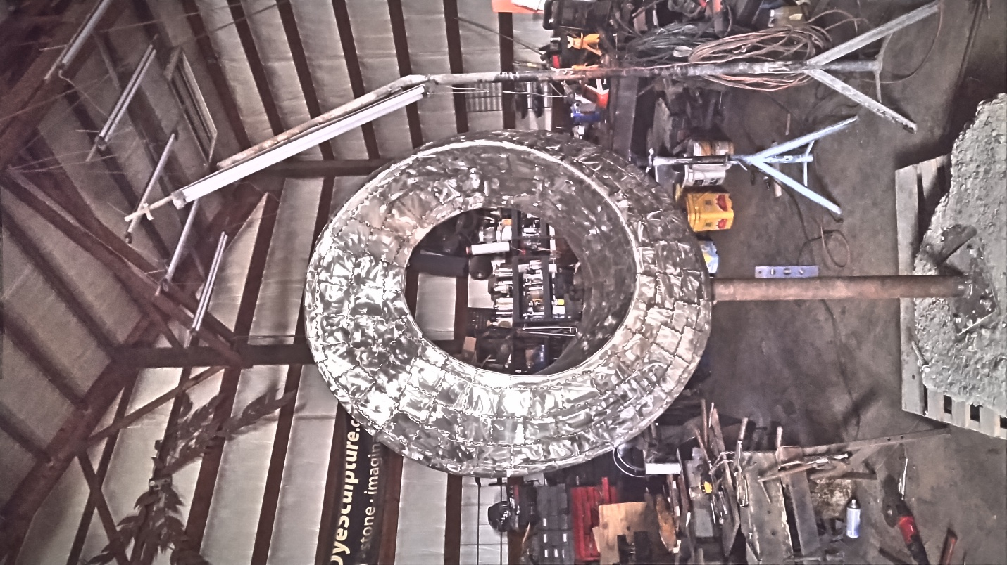
    - 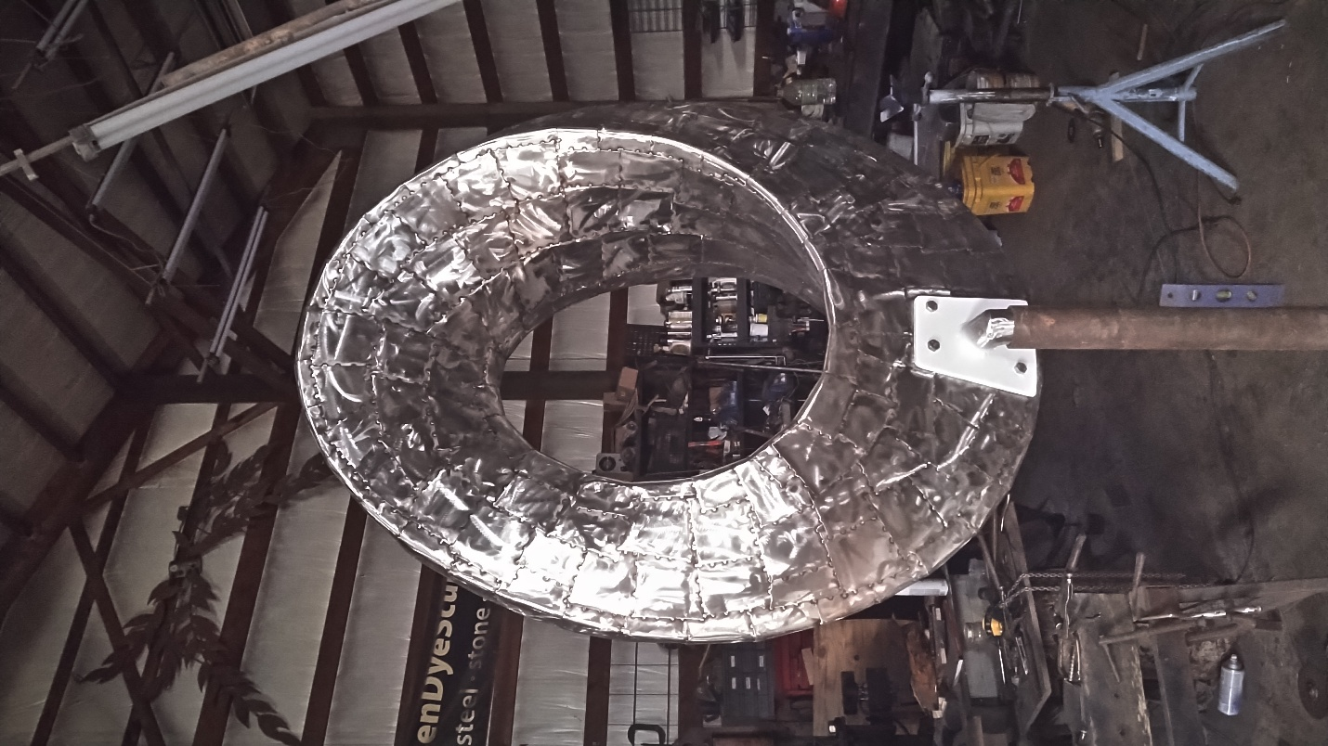
    - 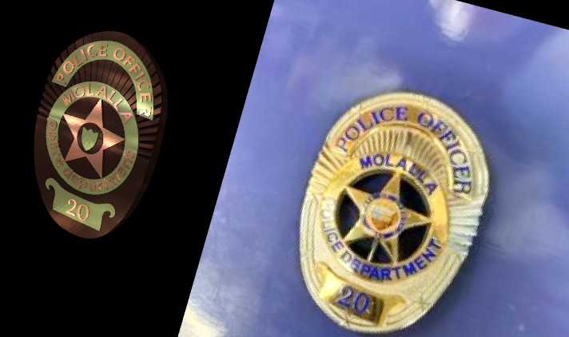

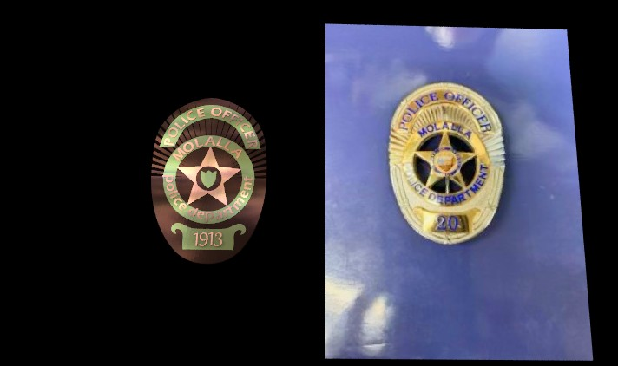

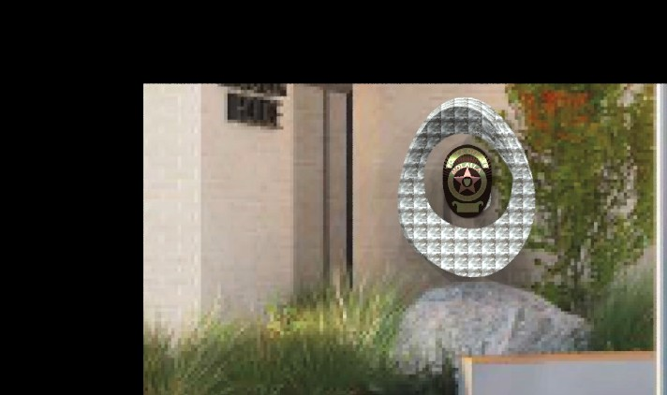

* *Good morning, The Mobius is completed, and we are ready to discuss the final design of the badge.*
* *Here are images of the completed Mobius and renderings of the Badge.*
* *If anyone from the committee would like to schedule a site visit to see it, let me know.*
* *The badge is rendered with Bronze, copper and brass as colors. I alternated them to emphasize contrast.*
* *To fit the mobius proportions, the badge is depicted as 18'' tall.*
* *After the committee approves the badge, I will begin that phase.*
* **FOR THE GOOD OF THE ORDER**
* **ADJOURN**