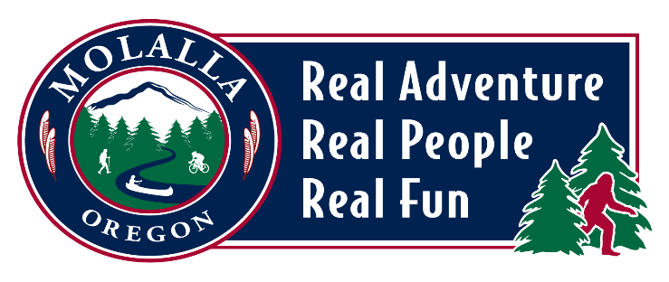

**CITY OF MOLALLA**

**BEAUTIFICATION & CULTURE COMMITTEE**

**MEETING AGENDA**

**Meeting Location: Molalla City Hall**

**117 N Molalla Avenue**

**Monday, June 16, 2025 | 5:30pm**

* **CALL TO ORDER & WELCOME**
* **ROLL CALL**
* **MINUTES**
  + **April 21 Minutes for approval**
  + **No May 19 Minutes as meeting cancelled**
* **GENERAL BUSINESS** 
  + **Tree Lights – Connie**
  + **Molalla PD Art update-Leota**
  + **Flag and placard at Billy Sheets Field – Suzanne**
  + **Banner Holder – Leota**
* **OLD BUSINESS**
* **FOR THE GOOD OF THE ORDER**
* **ADJOURN**